Eric I-Jui Lee (cs61bl-hm)
James Sha (cs61bl-ep)
CS61BL Summer 2012 Project 1
Runtime Analysis of the blur Method
Summary:
The runtime of the method Picture.blur(int blurThreshold) is analyzed. The method used is the measurement and subsequent analysis of the time required to process images of varying sizes and incorporating different blur thresholds. The runtime is found to be proportional to the area of the image times the square of the blur threshold.

Introduction:
In image manipulation, it is sometimes necessary to blur an image for smoothing out edges and creating effects. While many different algorithms can be used, the simplest one is the “average method”. For each pixel (which we will call the reference pixel) in the new image, the component colors of all pixels in a square of side (2 × blur threshold) + 1 centered at the reference pixel in the original image are averaged individually and set as the reference pixel’s colors. For example, if the blur threshold is 2, and the current pixel is at location (8,10), then we are considering pixels in a 5 × 5 square that has corners at pixels (6, 8), (10, 8), (6, 12), and (10,12), as shown below. The red, blue, green and alpha values are averaged separately. If the square extends past the borders, only pixels within the image are taken into account and averaged.
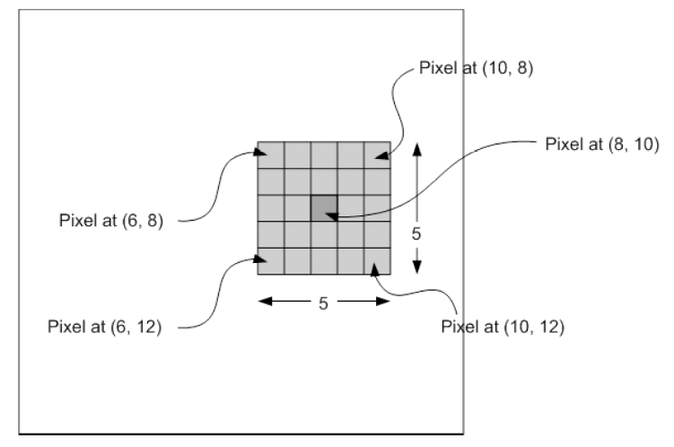
Figure 1: visual representation of how pixels are selected for averaging.
Methods:
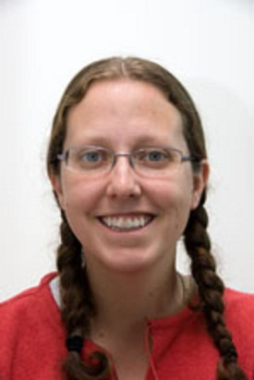
Fig. 2: Image used in tests below
By measuring the physical time required to process images under different parameters, a relationship should surface. Three different sizes of the same image, shown in Figure 2, are used for resting. For each size, five different blur thresholds are tested, and the runtimes are measured.

In order to reduce noise, a sample size of 12 is taken. Then, after discarding the shortest and longest time, the rest are averaged.

Evidence:
Below is data for runtime in seconds under various image sizes and blur thresholds:

Image size | Blur Threshold
Image size | 1 | 2 | 3 | 4 | 5
Small  (150 × 244) | 0.106 | 0.245 | 0.447 | 0.714 | 1.067
Medium  (300 × 488) | 0.415 | 0.967 | 1.833 | 2.909 | 4.287
Large  (450 × 732) | 0.917 | 2.203 | 4.086 | 6.582 | 9.695

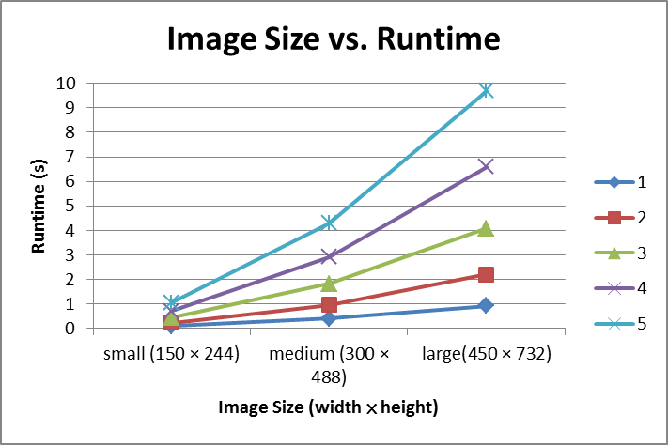
Fig. 3: Graph 1—Relationship between image size and runtime.
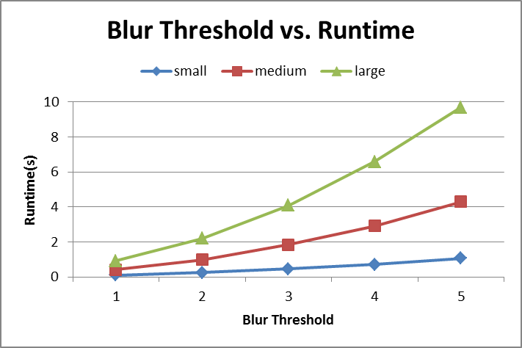
Fig. 4: Graph 2—Relationship between blur threshold and runtime.

Conclusions:
Through analysis, it is evident that the runtime of blur is proportional to the area of the image it is processing as every pixel in the image must be processed. In addition, for each pixel processed, a maximum of ((2 × blur threshold) + 1)² nearby pixels are averaged, which is proportional to the square of the blur threshold. Combining these two factors, we can see that running blur takes time proportional to A × R², where A is the number of pixels in the image (area) and R is the given blur threshold. This result arrives from the fact that the algorithm processes A number of pixels and for each must average a number of other pixels is at most proportional to R². The empirical test results follow such a pattern.

Examining the first graph, it is easy to see that runtime growth rate increases as the size of the processed image increases. The medium image (four times the area of the small image) takes about four times longer to blur as the small image, while the large image (nine times the area of the small image) needs almost 9 times the time of the small image to process, consistent with the predictions above. As an example, the ratio of the three trials with a blur radius of five is 1:4.018:9.085, very close to the theoretical value.

The second graph demonstrates the influence of the blur threshold on the runtime. It seems to suggest a quadratic relationship between the two. For the medium-sized image, blur thresholds of 3, 4, and 5 are produce runtimes of 1.833, 2.909, and 4.287 seconds. The ratio of the three results is 1:1.60:2.41, which is somewhat smaller than the theoretical ratio of 9:16:25 (1:1.78:2.78). The reason for this discrepancy is the result of the generalization. It was stated before that each pixel is the average of at most ((2 × blur threshold) + 1)² pixels. For pixels near the border, this is untrue. Fewer pixels are averaged for border pixels since ones outside the scope of the image cannot be processed. This actually decreases the runtime of blur, causing the deviation from our prediction. Depending on the size of the image, these pixels should be a minority (barring exceptionally small images or exceptionally large thresholds). As a result, the runtime lies close to the prediction.

